Unit 356 Board Meeting

February 19, 2024

Minutes

Present: Jack Shoemaker, Steve Reynolds, George Harger, Tara Evans, Sheri Morris, David Pearlman, and Suzanne Greenwood. Ken Grafton was absent.

Meeting called to order at 10:02 AM. Minutes of the January meeting were approved.

Steve provided a District 17 update, discussing –

* Issues with regional tournaments, and the possibility of a Tucson Regional.
* A reception with Regional board members after the Wednesday afternoon session of the Winter Regional Tournament.

George provided the financial report. The Unit made $3,000 in the first two months of the 2024. Investments are doing well. The tournament is expected to produce positive revenues. He has talked with Chase Bank about fees and expects to have a discussion after the tournament, when we’ll see how much cash we have. We may also be able to reduce our service fee if we invest in a Chase CD.

Tara reported that membership is at 922. We had 3 new members; 2 renewed, and 3 transferred.

Sheri reported that she was talking to Saddlebrooke people currently in Unit 351 or other Units about transferring to 356, primarily so as to get Unit communications.

ACBL’s 5/5/5 program (Unit Retention and Recruitment Plan) will begin on April 1. The Unit will get 11% of renewals. Jack and Sheri will get together to figure out how to get the maximum benefit from this program.

Jack discussed the Winter Regional, including setup, dealing with a larger number of tables, setup for speakers, Welcome Desk posters, and food/snack service. Jack and Sheri have done a walk-through.

Suzanne discussed doing a morning snack. The board agreed distribute a wrapped snack (e.g., 5 $10 boxes from Costco), to provide small creamer packets, and subs from eegees for the Saturday lunch.

Tara discussed supplies of calendars, patches, pencils, for the welcome bag.

Sheri will get additional boards from Adobe.

David discussed Adobe’s need for a Lead Director to replace Eric Swanson and putting something on the welcome table (and other appropriate socialization) about search for this job.

The Board agreed to continue the current subsidization of certain ACBL table fees for Unit games at clubs.

Jack noted that there will be a ceremony honoring Mini-McKenney/Ace of Clubs winners on April 7.

The next Board meeting will be March 20.

On motion by Mike, seconded by Sheri, the meeting was adjourned at 11:07 AM.

Respectfully submitted,

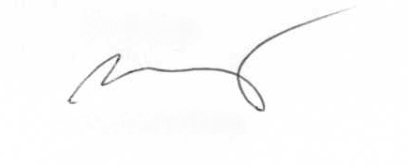

Michael Barry, Secretary